**Lab:** Test Driven Development

Task to perform

On the base of the document “[***Learning Test Driven Development.pdf***](Learning%20Test%20Driven%20Development.pdf)” develop on **Java** the following Use Case functionality using Test Driven Development (TDD) approach.

As you remember, the algorithm of TDD is:

[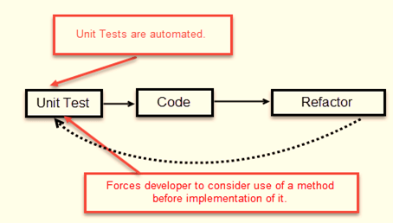](https://cdn.guru99.com/images/8-2016/081216_0811_TestDrivenD1.png)

1. Write a test
2. Make it run.
3. Change code to make it right i.e. Refactor.
4. Repeat process.

For an example how to write a test see: [***How to write a test.pdf***](How%20to%20write%20a%20test.pdf)

**Use Case description:** As a user, I need that a program will create a group of students. I need also that I could add a student, delete and edit it.

**Notes:** There is a lot of examples of TDD on Internet (<https://www.youtube.com/watch?v=2Ekty7t621k>)